**7 things you can self-host today that have nothing to do with media or file storage**

Story by Megan Ellis

When it comes to self-hosting, many people start out with media servers and self-hosted cloud storage for files, documents, and photos. It's what makes tools like Nextcloud, Jellyfin, and Immich so popular. But there are actually plenty of other types of software you can host on your own server.

While I've experimented with self-hosted streaming services and cloud storage in the past, when I really took a dive into self-hosting this year, I was surprised by just how many things you can host. It sometimes feels like there's a self-hosted app for everything. Here's a look at some of the [useful self-hosted apps](https://www.xda-developers.com/self-hosted-services-now-love/?utm_source=syndication&pubDate=20250812) and platforms you can try out today.

**Note-taking software**

**Keep your notes synced and private**

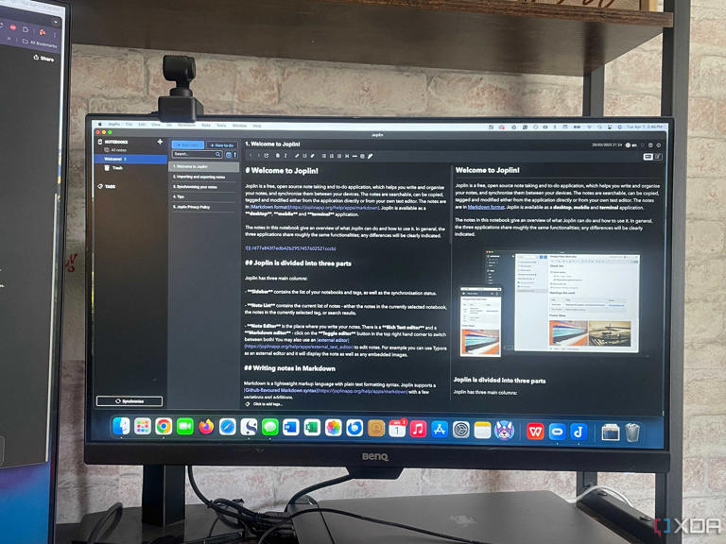

A shot of Joplin in use on a computer.

While much of my note-taking happens in Google Keep and various documents, I've spent the past year exploring more powerful apps like Notion and Obsidian. But I was pleasantly surprised when I explored alternatives to these powerful apps that you can also self-host.

Joplin and TriliumNext Notes are two popular options for self-hosted note-taking apps. You can [install Joplin Server on a Raspberry Pi](https://www.xda-developers.com/install-joplin-serven-raspberry-pi-other-linux-servers/?utm_source=syndication&pubDate=20250812) using Docker, though setup can be a bit tricky if you're not familiar with coding. You can also [self-host TriliumNext Notes](https://www.xda-developers.com/reasons-self-host-triliumnext-notes/?utm_source=syndication&pubDate=20250812), but the documentation recommends using a valid TLS certificate for syncing your notes to a self-hosted server.

However, there are plenty of options available that aim to address different user needs. If you host a Nextcloud server, you can also use the Nextcloud Notes app. Meanwhile, [Memos offers a lightweight interface](https://www.xda-developers.com/this-self-hosted-markdown-editor-is-my-new-favorite-way-to-take-notes/?utm_source=syndication&pubDate=20250812) that still packs in a bunch of functionality.

**Productivity and task apps**

**Sync your to-do list with your own server**

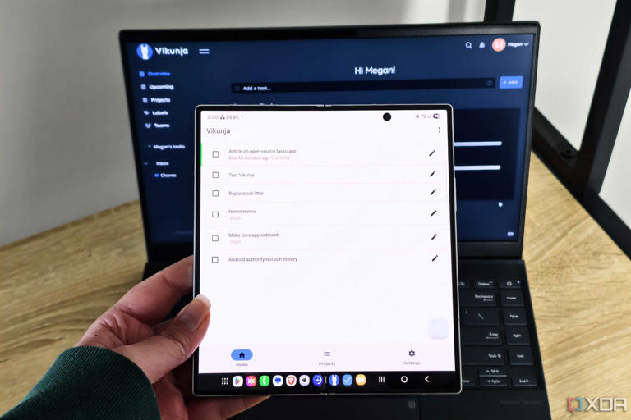

vikunja app on a foldable phone with a laptop in the background

To-do list apps are another type of software that you can self-host, with some great and user-friendly options out there. I recently [self-hosted Donetick to help me with my chores](https://www.xda-developers.com/self-hosting-donetick-for-chores/?utm_source=syndication&pubDate=20250812) because I was struggling with notification fatigue from my current task apps.

But I've also ventured into self-hosting Vikunja, with easy syncing between my NAS and the Android app. You can also self-host Tasks.org, but I noticed that syncing with the app requires a paid subscription.

In addition to to-do list apps, there are also more general productivity apps that you can self-host. Apps like AppFlowy and Wekan allow you to track the progress of tasks with Kanban boards. Meanwhile, YouTrack offers an entire project management app.

**Financial and budgeting software**

**Control your money without spending any**

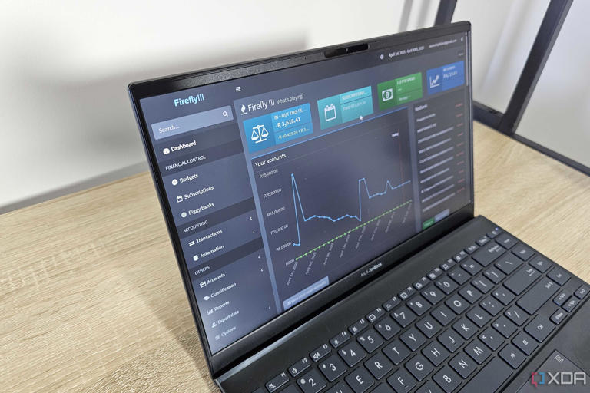

firefly iii dashboard on a laptop

Self-hosted apps can save you money by removing the need to rely on remote servers with subscriptions. But they can also help you [keep track of your finances](https://www.xda-developers.com/i-self-host-these-5-apps-to-manage-my-finances/?utm_source=syndication&pubDate=20250812), subscriptions, and monthly budget.

Wallos is a useful app that allows you to manually track your subscriptions. Meanwhile, Firefly III offers powerful features that you can use to keep track of your finances. It also supports syncing with certain banks, as well as robust automation rules.

If you need help managing your budget, you can also self-host a budgeting app. My next project is self-hosting Actual Budget to see if the software can help me get better control over my own finances.

**Smart home apps**

**Say goodbye to vendor lock-in**

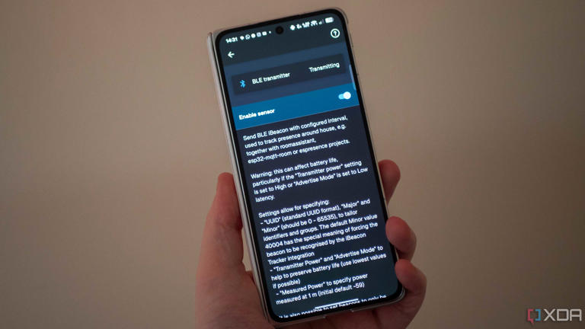

BLE transmitter settings in the Home Assistant app on Android

I love my smart home devices, but I also get frustrated when Google Home stops playing nicely with third-party devices or the platforms try to push me into a paid subscription. Luckily, you can also self-host smart home platforms.

When it comes to self-hosted smart home apps, Home Assistant reigns king. It is one of the self-hosted software platforms that I'm most excited about trying, but I need to save up for the hardware I need to run my own server, since my NAS doesn't have sufficient resources.

Home Assistant has tons of integrations available, as well as [useful add-ons](https://www.xda-developers.com/install-home-assistant-add-ons-first/?utm_source=syndication&pubDate=20250812) that can expand the functionality of the app. But it's not the only self-hosted smart home platform available. OpenHAB is another option that supports plenty of integrations. Meanwhile, Frigate allows you to manage your security camera feeds, and Gladys Assistant is a self-hosted smart home assistant.

Some platforms include automation features, while others can be paired with an automation platform to unlock more features. And speaking of automation...

**Automation platforms**

**Powerful Zapier alternatives**

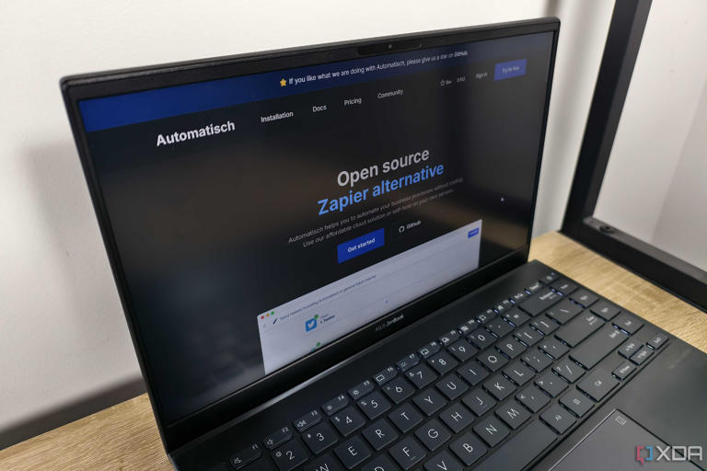

the automatisch website on a laptop

I dabbled in automation back when IFTTT was at its prime, but mostly stopped using it due to the limitations of its free plan. When I tried out Zapier automations, I realized just how much can be done nowadays with the right automation platform.

Thankfully, you can self-host automation platforms, too. I did this with Automatisch, and I love the platform's no-code approach to creating workflows. This made it relatively easily to set up a variety of automations without needing coding skills.

But if you do have coding skills, then n8n unlocks powerful automations that you can use. Other options available include Node-RED and Huginn.

By combining self-hosted smart home apps with self-hosted automation apps, you can also create really nuanced automations for your smart devices and sensors.

**Personal dashboards**

**Dashboards for your self-hosted services**

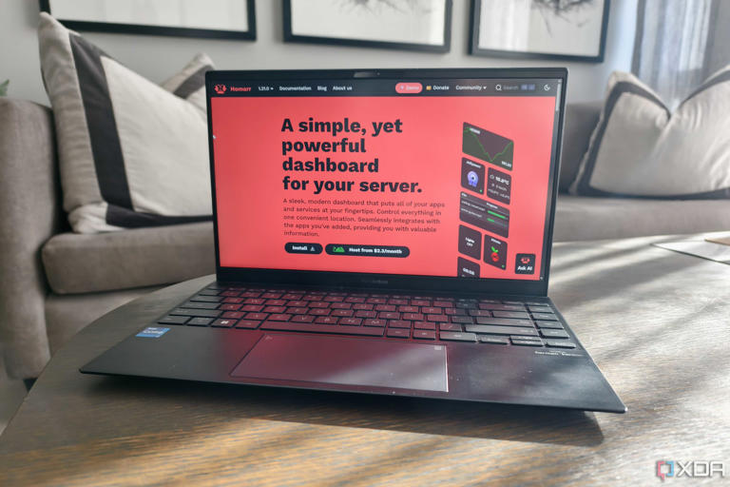

a laptop showing the homarr website

As you self-host more services, things can get a little chaotic, especially if you didn't plan out everything from the start. But that's where self-hosted dashboards come in. You can use these tools through your browser to manage and access your self-hosted apps, giving you shortcuts to your most essential tools.

I use [Homarr to organize my self-hosted services](https://www.xda-developers.com/homarr-dashboard-for-self-hosted-apps/?utm_source=syndication&pubDate=20250812" \t "_blank), but will also likely check out other dashboards as I move most of my self-hosted services to my NAS. Other popular options are Heimdall and Homepage.

The benefits of these dashboards include providing a comprehensive overview of your services and their status, ensuring your data remains private, and allowing for extensive customization. For example, I was surprised that I could set up an RSS feed using Homarr that pulls the latest articles from XDA.

**Security tools**

**Privacy on privacy**

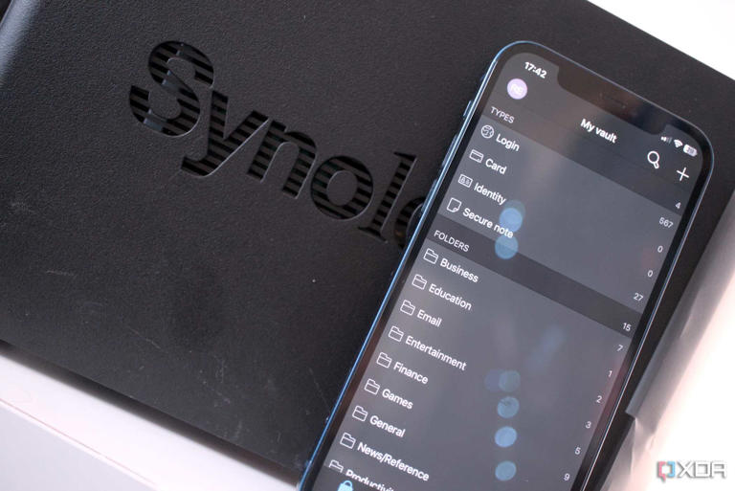

Bitwarden with Synology NAS

Privacy and control over your own data are some of the benefits of self-hosting, so it makes sense that there are tools specifically dedicated to security and privacy that can also be self-hosted.

I personally access most of my self-hosted tools within my home network since I want to make sure I have reliable security in place before I expose any of my ports. While I may not opt for a self-hosted solution, I am amazed at just how many security tools can be self-hosted.

These range from VPNs, network filters, and authentication services, to password management and reverse proxies. While many of the types of services I've listed can be self-hosted by relative beginners, security tools require a lot more technical knowledge, especially around the potential threats you face on the internet.

But the range of tools available is great to see, especially since securing your home network and home lab is an important part of self-hosting.

**There's plenty more that you can self-host**

I used to associate self-hosting mostly with a personal cloud and media streaming, but the past few months I've spent trying out different services have shown me just how much there is available out there. I understand [why people don't self-host](https://www.xda-developers.com/why-people-dont-self-host/?utm_source=syndication&pubDate=20250812), and there have been times when I've wanted to throw in the towel due to my lack of coding knowledge (which makes troubleshooting very difficult).

But rather than giving up, I've motivated myself to try even more services and platforms that fall into my own technical wheelhouse, since there's just so much you can do. I do plan to expand my skills in the future so that I can try out even more apps and hopefully contribute to fixes and troubleshooting. In the meantime, however, there are numerous options available for me to try.